Pintar, Matthew R. and W. J. Resetarits, Jr. Prey-driven control of predator assemblages: zooplankton abundance drives aquatic beetle colonization. Ecology. 2017.

Appendix S1

Table S1: F statistics and P values from repeated-measures ANOVAs for the water change experiment: total beetle abundance, species richness, Dytiscidae, Hydrophilidae, and species with N > 100, in rank order of abundance by family (see Table 1). Bold indicates statistical significance (P < 0.05)

 | Between pools |  |  | Within pool
 | Age  df (1,18) | Block  (3,18) |  | Time  (33,693) | Age  × Time  (33,693)
Total abundance | 11.907 | 1.117 |  | 58.035 | 2.584
 | 0.0029 | 0.3684 |  | <0.0001 | <0.0001
Species richness | 11.018 | 1.195 |  | 45.704 | 1.814
 | 0.0038 | 0.3398 |  | <0.0001 | 0.0039
Dytiscidae | 20.57 | 0.91 |  | 50.812 | 5.592
 | 0.0003 | 0.456 |  | <0.0001 | <0.0001
Copelatus glyphicus | 10.461 | 2.361 |  | 33.020 | 4.113
 | 0.0046 | 0.1054 |  | <0.0001 | <0.0001
Laccophilus proximus | 9.730 | 1.851 |  | 24.985 | 4.163
 | 0.0059 | 0.1742 |  | <0.0001 | <0.0001
Hydroporus rufilabris | 14.755 | 0.331 |  | 37.910 | 5.252
 | 0.0012 | 0.8027 |  | <0.0001 | <0.0001
Uvarus granarius | 8.119 | 0.355 |  | 12.247 | 3.199
 | 0.0106 | 0.7863 |  | <0.0001 | <0.0001
Laccophilus fasciatus | 5.369 | 4.677 |  | 4.830 | 1.160
 | 0.0325 | 0.0138 |  | <0.0001 | 0.249
Helophorus linearis | 1.234 | 2.694 |  | 23.965 | 1.774
 | 0.2813 | 0.0768 |  | <0.0001 | 0.0053
Hydrophilidae | 3.048 | 2.175 |  | 29.442 | 0.606
 | 0.0979 | 0.1263 |  | <0.0001 | 0.961
Paracymus | 4.289 | 1.265 |  | 30.855 | 0.616
 | 0.0530 | 0.316 |  | <0.0001 | 0.956
Tropisternus lateralis | 0.155 | 0.653 |  | 17.631 | 0.829
 | 0.6980 | 0.592 |  | <0.0001 | 0.741
Enochrus ochraceus | 7.406 | 0.287 |  | 11.487 | 1.874
 | 0.0140 | 0.834 |  | <0.0001 | 0.0024
Berosus infuscatus | 0.488 | 5.638 |  | 7.725 | 0.791
 | 0.4937 | 0.0066 |  | <0.0001 | 0.794

Table S2: PERMANOVA results from the water change experiment. Block was rolled into the error term when P > 0.25. Bold indicates statistical significance (P < 0.05)

Source | df | SS | MS | Pseudo-F | P | Unique perms
Period 1
All beetles
Age  Residuals | 1  22 | 2139.9  12354 | 2139.9  561.5 | 3.8109 | 0.001 | 999
Dytiscidae  Age  Block  Residuals | 1  3  19 | 2854.4  2491.5  12071 | 2854.4  830.5  635.3 | 4.4927  1.3072 | 0.001  0.193 | 999  997
Hydrophilidae  Age  Residuals | 1  22 | 2033.1  11812 | 2033.1  536.9 | 3.7865 | 0.014 | 995
Period 2
All beetles
Age  Block  Residuals | 1  3  18 | 1358.3  1742.2  6961.6 | 1358.3  570.7  386.8 | 3.5121  1.5015 | 0.005  0.108 | 998  998
Dytiscidae  Age  Residuals | 1  21 | 2270.2  8818.8 | 2270.2  419.9 | 5.4061 | 0.003 | 999
Hydrophilidae  Age  Block  Residuals | 1  3  18 | 580.0  2393.5  5683.8 | 580.0  797.8  315.8 | 1.8368  2.5266 | 0.119  0.005 | 999  998
Period 3
All beetles
Age | 1 | 970.6 | 970.6 | 1.3074 | 0.247 | 998
Residuals | 21 | 15589 | 742.3
Dytiscidae
Age | 1 | 1694.1 | 1694.1 | 1.6841 | 0.142 | 997
Residuals | 21 | 21124 | 1005.9
Hydrophilidae
Age | 1 | 555.5 | 555.5 | 0.8883 | 0.539 | 999
Residuals | 21 | 13133 | 625.4

Table S3: Results of zooplankton repeated-measures analyses from both experiments. Block was not significant (P > 0.25) in the water change experiment for all analyses and was rolled into the error term. Ostracod abundances were too low in the inoculation experiment (N = 10) for meaningful analysis but were included in the total zooplankton analysis. Bold indicates statistical significance (P < 0.05)

 | Between pools |  |  | Within pool
 | Treatment | Block |  | Time | Treatment  × Time
Water change experiment | df (1,21) | No test |  | (2,42) | (2,42)
All zooplankton | 44.53 |  |  | 36.52 | 17.44
(N = 7866) | <0.0001 |  |  | <0.0001 | <0.0001
Cladocera | 13.45 |  |  | 22.021 | 6.153
(N = 2442) | 0.0014 |  |  | <0.0001 | 0.0045
Copepoda | 33.0 |  |  | 13.046 | 4.484
(N = 2294) | <0.0001 |  |  | <0.0001 | 0.0172
Ostracoda | 4.593 |  |  | 0.021 | 0.733
(N = 132) | 0.044 |  |  | 0.980 | 0.486
Rotifera | 9.618 |  |  | 7.922 | 3.208
(N = 3005) | 0.0054 |  |  | 0.0012 | 0.0505
Inoculation experiment | df(1,17) | (5,17) |  | (1,22) | (1,22)
All zooplankton | 30.989 | 2.785 |  | 4.500 | 9.547
(N = 3579) | <0.0001 | 0.0515 |  | 0.0454 | 0.0054
Cladocera | 12.022 | 1.403 |  | 3.787 | 0.615
(N = 670) | 0.0030 | 0.2729 |  | 0.0645 | 0.4414
Copepoda | 8.151 | 3.167 |  | 1.512 | 7.580
(N = 2319) | 0.0110 | 0.0335 |  | 0.2318 | 0.0116
Rotifera | 6.396 | 0.056 |  | 1.339 | 1.459
(N = 580) | 0.0216 | 0.9976 |  | 0.260 | 0.240

Table S4: F statistics and P values from repeated-measures ANOVAs for the inoculation experiment: total beetle abundance, species richness, Dytiscidae, Hydrophilidae, and species with N ≥ 75 in rank order of abundance by family (see Table 1). Bold indicates statistical significance (P < 0.05)

 | Between pools |  |  | Within pool
 | Treatment  df (1,17) | Block  (5,17) |  | Time  (6,132) | Treatment  × Time  (6,132)
Total abundance | 9.796 | 23.334 |  | 47.569 | 1.866
 | 0.0061 | <0.0001 |  | <0.0001 | 0.0913
Species richness | 4.14 | 10.40 |  | 55.941 | 1.082
 | 0.0578 | 0.0001 |  | <0.0001 | 0.376
Dytiscidae | 17.357 | 8.258 |  | 24.847 | 4.605
 | 0.0006 | 0.0004 |  | <0.0001 | 0.0002
Laccophilus fasciatus | 9.773 | 6.601 |  | 23.502 | 5.419
 | 0.0062 | 0.0014 |  | <0.0001 | <0.0001
Hydroporus rufilabris | 34.02 | 20.81 |  | 4.948 | 1.482
 | <0.0001 | <0.0001 |  | 0.0001 | 0.1892
Copelatus glyphicus | 5.839 | 9.533 |  | 33.504 | 1.746
 | 0.0272 | 0.0002 |  | <0.0001 | 0.115
Hydrophilidae | 1.279 | 21.990 |  | 42.995 | 1.038
 | 0.274 | <0.0001 |  | <0.0001 | 0.404
Enochrus ochraceus | 2.256 | 13.384 |  | 17.039 | 1.273
 | 0.151 | <0.0001 |  | <0.0001 | 0.274
Tropisternus lateralis | 0.845 | 23.785 |  | 12.566 | 0.578
 | 0.371 | <0.0001 |  | <0.0001 | 0.747
Paracymus | 0.127 | 19.425 |  | 7.932 | 0.979
 | 0.726 | <0.0001 |  | <0.0001 | 0.442
Helochares maculicollis | 0.214 | 13.341 |  | 14.576 | 0.146
 | 0.649 | <0.0001 |  | <0.0001 | 0.99
Berosus infuscatus | 0.203 | 11.114 |  | 22.022 | 0.097
 | 0.658 | <0.0001 |  | <0.0001 | 0.997
Cymbiodyta chamberlaini | 0.153 | 3.372 |  | 4.368 | 0.251
 | 0.7003 | 0.0268 |  | 0.0005 | 0.9580
Enochrus pygmaeus | 0.968 | 16.352 |  | 2.875 | 0.436
 | 0.339 | <0.0001 |  | 0.0115 | 0.8535

Table S5: PERMANOVA results for the inoculation experiment. The reduced number of residual degrees of freedom in the dytiscid analyses is due to pools with 0 beetles, which cannot be included in these analyses. Bold indicates statistical significance (P < 0.05)

Source | df | SS | MS | Pseudo-F | P | Unique perms
Early
All beetles
Treatment  Block  Residuals | 1  5  17 | 2026.3  21892  10371 | 2026.3  4378.4  610.1 | 3.3215  7.1769 | 0.012  0.001 | 999  998
Dytiscidae  Treatment  Block  Residuals | 1  5  16 | 3714.9  21342  20003 | 3714.9  4268.4  1250.2 | 2.9715  3.4142 | 0.024  0.001 | 999  998
Hydrophilidae  Treatment  Block  Residuals | 1  5  17 | 812.0  19207  7795.9 | 812.0  3841.4  458.6 | 1.7707  8.3868 | 0.141  0.001 | 999  999
Late
All beetles
Treatment  Block  Residuals | 1  5  17 | 574.6  26174  15.689 | 574.6  5234.8  922.9 | 0.6627  5.6724 | 0.729  0.001 | 998  997
Dytiscidae  Treatment  Block  Residuals | 1  5  16 | 1848.6  24627  23679 | 1848.6  4925.5  1479.9 | 1.2491  3.3282 | 0.293  0.002 | 999  999
Hydrophilidae  Treatment  Block  Residuals | 1  5  17 | 296.1  25643  10177 | 296.1  5128.5  598.6 | 0.4947  8.5673 | 0.751  0.001 | 998  999

Fig S1: Multiple regression of (a) all beetles, (b) beetle species richness, (c) Laccophilus proximus, and (d) Uvarus granarius from the water change experiment against total zooplankton abundances in New and Old pools. Beetles were collected on 25 June and zooplankton on 22 June. Statistics are summaries of multiple regression results, with P values for effects of zooplankton abundance. N = total number of beetles for that sample date.

Fig. S2: Multiple regression of (a) all beetles, (b) beetle species richness, and (c) dytiscids from the water change experiment against total zooplankton abundances in New and Old pools. Beetles and zooplankton were both collected on 30 April. Statistics are summaries of multiple regression results, with P values for effects of zooplankton abundance. N = total number of beetles for that sample date.
Fig S3: Multiple regression of (a) all beetles, (b) beetle species richness, (c) hydrophilids, and (d) Tropisternus lateralis from the water change experiment against total zooplankton abundances in New and Old pools. Beetles were collected on 14 October and zooplankton on 16 October. Statistics are summaries of multiple regression results with P values for effects of zooplankton abundance. No dytiscids (N = 13) were abundant enough for analysis on 14 October.

Fig. S4: NMDS plots for (a) all beetles, (b) Dytiscidae, and (c) Hydrophilidae in the inoculation experiment. The box in (b) shows an inset of the data for clarity due to the outlier at the left side of the figure. Points are sorted by group and treatment and outlined in minimum convex polygons (outlier not included in (b)). Large block effects make it difficult to visualize significant effects of treatment in these graphs (see Table S5).
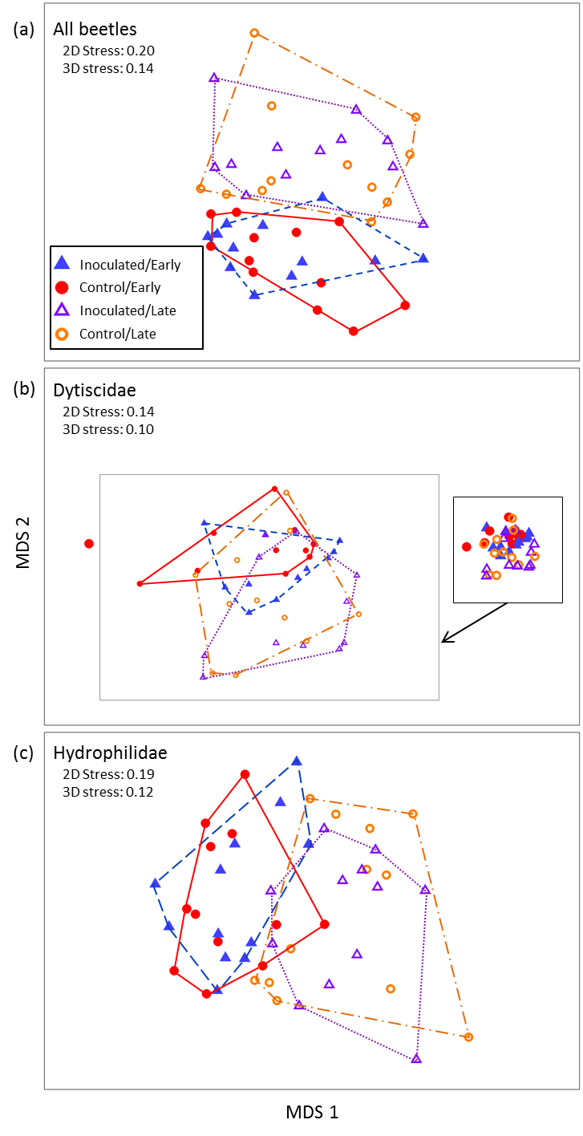
Fig S5: Multiple regression of (a) all beetles, (b) beetle species richness, (c) Enochrus ochraceus, (d) Helochares maculicollis, and (e) Tropisternus collaris from the inoculation experiment against total zooplankton abundances in New and Old pools. Beetles were collected on 5 November and zooplankton on 7 November. Statistics are summaries of multiple regression results with P values for effects of zooplankton abundance. There were large, significant block effects in all analyses in the inoculation experiment.

Fig S6: Multiple regression of (a) total beetle abundance, (b) beetle species richness, and (c) Hydroporus rufilabris from the inoculation experiment against total zooplankton abundances in New and Old pools. Beetles were collected on 19 November and zooplankton on 21 November. Statistics are summaries of multiple regression results with P values for effects of zooplankton abundance. There were large, significant block effects in all analyses in the inoculation experiment.

